Configure the mobile app for controlling motor using buttons

|  |  |
| --- | --- |
| Date | 20 November 2022 |
| Team ID | PNT2022TMID14999 |
| Project Name | Hazardous Area Monitoring for Industrial Plant powered by IOT |

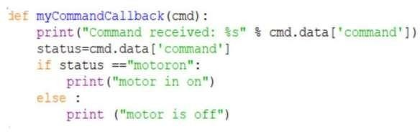**Python block:**

**Output:**

